**UCDE Group Assessment**

Computer Science  
University of York

**Interactive System Design**

**Reported by**

Shilina Alina

Feeney William

Zhang Xiang

Tan Ying

**Module leader**

Helen Petrie

Jo Iacovides

**Date**

November 2018

# TABLE OF CONTENTS

1 User Requirements Gathering 1

1.1 Online questionnaire method in gathering user requirements 1

1.2 Target user group 2

1.3 Analysis of collected information 2

1.4 User needs and goals 4

1.5 The description of two personas 4

*1.5.1* *European persona Harry* 5

*1.5.2* *Chinese persona Lai* 5

2 Scenario Based Design 6

2.1 Problem (as-is) Scenario 6

2.2 Claims analysis of the Problem Scenario 8

2.3 Activity (to-be) Scenario 8

2.4 Claims analysis of the Activity Scenario 9

3 Interactive System Prototype and Evaluation 9

3.1 Interactive System Prototype 9

*3.1.1**Finding out the environmental impact of a particular food & finding alternatives which have lower environmental impact* 11

*3.1.2* *Tracking the overall environmental impact of the food and making comparisons with the “diet for two degrees” targets* 11

*3.1.3* *An ability to make a reasonable meals plan before going to the shop* 12

3.2 Expert Inspection Evaluation of the Prototype 13

3.3 User Evaluation 13

CONCLUSION 13

REFERENCES 16

APPENDIX 17

# User Requirements Gathering

This chapter contains an explanation of undertaken method in gathering user requirements, the description of a target user group and why we focus on this group, the analysis of collected data, the description of user needs and goals and the description of two personas (European and Chinese).

## Online questionnaire method in gathering user requirements

Understanding user needs and goals is the key point in designing every application. According to Preece, “these needs form the basis of the product's requirements and underpin subsequent design and development” [1, p.169]. For this reason, understanding user goals is the crucial factor that lies in the basis of every design. To understand what users want to see in the application, we gathered data through an online survey questionnaire as this method is the most suitable for collecting quantitative and qualitative data. What is more, it enables to collect data from a large group of people in quick and less time-consuming way: people reach questionnaire just through a one “click” as questions are in an electronic format. The main purpose of collecting data in our case is to get information about how people make decisions while buying food, what influences their preferences and priorities, why they choose a concrete type of products.

In order to collect data from people, we use “*Qualtrics*” software which helps to manage data in convenient way and enables to get information in visualized charts, statistics reports and others.

One of the very important point in data gathering through questionnaire is to explain user what they are supposed to do and what type of questions they will meet. For this purpose, we created an introduction part which makes users clear what they should do, how long it will take and who will have access to their data (confidentiality issues). Having this introduction part in the questionnaire, we contribute to user’s knowledge about the research and, thus, make a good impression on them and command loyalty of people.

To obtain more consistent and high in quality information, we use a wide range of different questions. The total number of questions is 30. The questionnaire starts with closed basic demographic information, gender, age and e.t.c. As Preece underlines, “this background information is useful in finding out the range within the sample group” [1, p. 398]. All questions in the questionnaire can be split to eight different parts that help us to collect well-organised and coherent information: user group, user’s opinions on planet contamination and “diet for two degrees”, user’s food preferences, user’s attitudes to price of products, user’s attitude to their health, user’s attitude to their figures, user’s attitude to time spent on food preparation, conclusion questions that summarize the information from all of the parts. To obtain data in different ways, we use a mix of scales, open & closed questions, reverse items (a mix of positively and negatively phrased questions), multiple selection questions.

To summarize, the designed questionnaire helped us to collect high in quality, sufficient and relevant information and to produce a set of stable requirements which assist us to design a usable application that helps people to support their efforts to change their diet in line with the WWF proposal.

The link to view the questionnaire:

<https://york.qualtrics.com/jfe/form/SV_55VNxkPPRS8ljiR?fbclid=IwAR1ftslEZJeazqNmgzaXtjDE1HCzbmNHbsbdLPDM4jPdH3F_6f-DMHm89RM>

## Target user group

Understanding how user requirements influence design solutions, “may help you as a designer to better develop a successful product” [2, p. 54]. Moreover, having a clear understanding who will use an application and what problems this application may assist to solve, contributes to design a high in quality product which would have a convenient usability. Since our goal is to design an application that people can consult on their smartphone when they are shopping, we should decide who will be potential users of the application. It helps us to produce an app that would satisfy Norman’s fundamental principles of interaction: affordances, signifiers, constraints, mappings, feedback [3, p.10].

Usually, universities in the UK provide students with the information about environmental contamination, carbon dioxide emissions, overall planet pollution in order to struggle with these global environmental problems (recycling, using more buses rather than own cars, bicycles). As a result, students in the UK universities have more knowledge about environmental issues and, thus, make more efforts to overcome these pollution challenges. For this reason, we decided to design an application for students of University of York. Moreover, resources available on campus for these target group are easy to access and convenient to gather sufficient information.

## Analysis of collected information

1. *Identifying user group:*

In questionnaire took part 44 participants between 19-50 ages, 25 males and 19 females. 38 from all participants are students. The students are from different countries such as Canada, China, the United Kingdom, Japan, Nigeria, Russian Federation, South Africa. The majority of people were from China (19) and the United Kingdom (17) which is 45% and 40% in percentage respectively.

1. *Identifying user’s opinions on planet contamination and “diet for two degrees:*

37 participants care about planet and only 5 don’t bother about it. Moreover, 35 persons think that there is an inevitable connection between food and environmental issues. As it can be seen from a scale question, that in intended to understand whether people want to change their diet to help to restrict climate change, 50% of all people think that changing their diets would help to restrict climate warming. In summary, the majority of participants are conscious about environmental problems and want to make a contribution to overcome these challenges.

1. *Identifying user’s food preferences:*

It is revealed, that the most typical lunch plate is: meat, some vegetables and carbohydrates. Only 2 persons are vegans, 3 are vegetarians, 1 is pescetarian and other don’t follow any diet. Based on the answers, we can conclude that the most favourite food is something that contains meat.

1. *Identifying user’s attitudes to price of products:*

The most popular places for buying products are supermarkets and food chains with 34 and 17 responses respectively. The similar number of people (7) buy food at retail stores and markets. From a scale question, which is intended for collection data whether people buy products on sale or not, we can conclude that the majority of people 65% prefer to buy food on sale and only 12% of all participants prefer to buy more expensive products rather than cheap. In other words, the price of the product has a significant value for people.

1. *Identifying user’s attitude to their health:*

91% of all respondents would want to change their eating habits if it is good for their health. Similarly, 77% of all participants would want to pay more for food if it contributes to their health. Overall, it means that bulk of people care about their health and are willing to change their way of life for the sake of their well-being.

1. *Identifying user’s attitude to their figures:*

As it can be seen from collected data, 37 people care about their figures and try to eat less harmful food that keeps them fit. However, the majority of respondents (60%) don’t buy food because it is low in fat and almost the similar number of people don’t try try to avoid sweets or treats because they are high in calories – 46% and 54% respectively. In summary, the majority of participants cares about their figures but don’t want to buy products which can help them to stay fit.

1. *Identifying user’s attitude to time spent on food preparation:*

Only 21 answers show that people prefer to prepare food at home if they have to eat out of the house. In contrast, 53 answers display that people prefer to have a lunch out of the house (café, restaurant, fast-food or buy snacks). In other words, the majority of respondents don’t want to spend time on food preparation. It is proved by question whether people care how long a meal takes to cook: 33 persons answered “yes” and only 9 “no”.

1. *Conclusion questions that summarize the information from all of the parts:*

In conclusion, as it can be seen from data collected, the main important factors while choosing food are price with 23% responses, taste with 20% responses, nutritional value (health impact) and shelf life with 14% and 11% responses respectively. Less but not the least important factors are preparation time (9%), brand (7%), packaging (6%). The least important factors with the same number of answer percentage (3.7%) are environmental impact, ingredients and impact on figure. The analysis of conclusion questions are shown in Fig. 1.

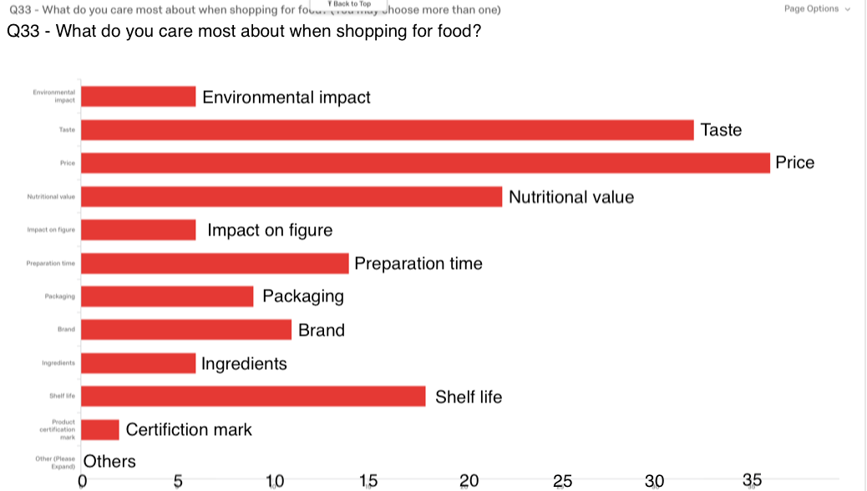

Fig. 1. The analysis of conclusion questions

## User needs and goals

From collected data, we can define user needs and goals:

1. know how much time is required to prepare meal;
2. know alternatives which are better for environment;
3. be able to make a reasonable meals plan before going to the shop (app would suggest ingredients with lower environmental impact), save it to a phone, and see the ingredients to buy when a person is at the shop;
4. know the nutritional value of a concrete food
5. know how much time is required to prepare meal;
6. be able to compare two products (by nutritional value, price, kcal…)
7. add food preferences to the application and view automatically generated receipts with these favourite products.

**A short explanation of three user needs**

1. *Know the nutritional value of a concrete food*

As it can be seen from the questionnaire, 39/44 people answered that they would be willing to change their eating habits if it is good for their health. What is more, 33/44 are willing to pay more for food if it has clear benefits to their well-being. In other words, people are concerned about their health and, thus, they require information about the nutritional value of food. Having access to that information, they can analyse which type of food would contribute to their health or would have a harmful impact.

*2. Know how much time is required to prepare meal*

As a questionnaire reveals, 33/44 participants care how long a meal takes to cook. Moreover, 25/44 persons prefer to cook dishes with 1-3 ingredients: such meals are easy to cook and, thus, it saves time. That is to say, people don’t want to spend a lot of time on food preparation. Thus, people need to know how much time is required to prepare the dish. This option would make it possible to plan how much time they will spend on food preparation and, as a result, they would be able to create a daily schedule more accurate.

1. *Know alternatives which are better for environment.*

21/44 participants said they would be willing to change their diet if it was better for the environment. However only 6 people responded that they follow an alternative diet like vegan or vegetarian. We can see that nearly 50% of those surveyed said they were willing to change their eating habits and 6 people had already changed from a omnivorous diet. Also it reveals that 22/43 participants planned meals before buying food and a further 15/43 sometimes planning meals it means that people are actively seeking out recipes and then purchasing the ingredients. In the planning stage of a meal it would provide a great opportunity to suggest alternative ingredients that have a smaller impact on the environment. For example, if they want to make a beef stroganoff it may suggest a mushroom stroganoff as beef has a greater environmental impact [I will add the reference].

## The description of two personas

As the majority of all respondents were British people (19/44) and Chinese people (17/44), we decided to describe two personas from these nationalities. Below you can find the description of each persona based on the data collected.

### *European persona Harry*

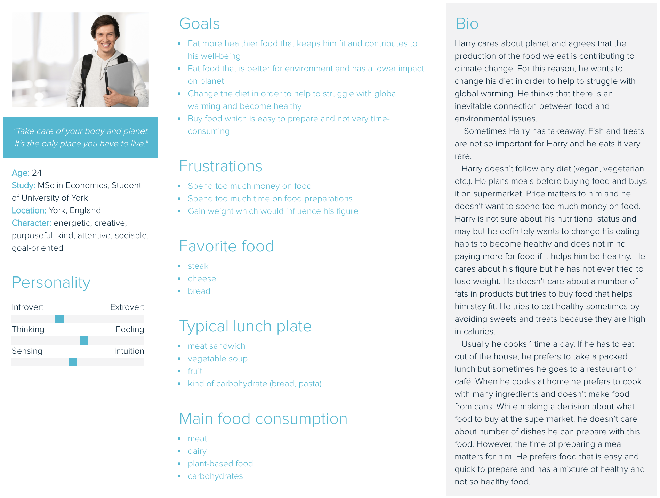

### *Chinese persona Lai*

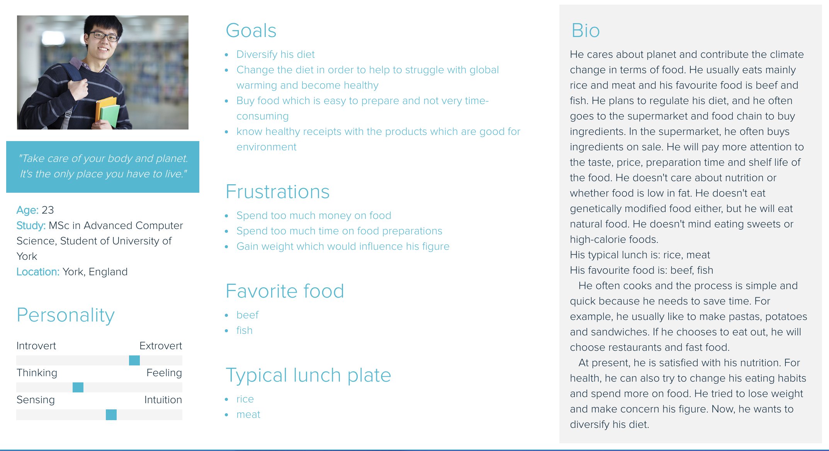

# Scenario Based Design

According to Caroll, “the scenario emphasizes and explores goals that the user may adopt and pursue” [4]. For this reason, creating scenarios would contribute to deeper understanding of user needs and goals and, thus, facilitate in development an application with convenient usability and interface. Moreover, as Rosson emphasizes, scenarios “enable rapid communication about usage possibilities and concerns among many different stakeholders” [7, p. 3].

The designed application is going to be used by students of University of York who are concerned about an environment and want to change their diets to mitigate climate change problem. It will assist them to make a right choice, i.e. to buy food which has lower environmental impact and which helps to restrict global warming challenge.

In addition to user tasks identified in Part 1.1 (1.4 User needs and goals) with this smartphone application people will be able to complete the following tasks:

1. find out the environmental impact of a particular food;
2. to list alternatives to that food which have lower environmental impact, including information about cost and nutritional differences;
3. track the overall environmental impact of the food they purchase and compare with the “diet for two degrees” targets;
4. filter alternatives by price, by nutritional value, by closest supermarket where they can buy a concrete product.

The criteria by which users will know they have accomplished their goals are listed below:

* as users strictly control the daily intake of meat and eat more plant-based food, the overall carbon emissions reduce; in other words, a reduction in emissions of 60% [5, p. 5];
* as users eat more vegetables and wholegrains, they have stronger health. Moreover, “this lead to Livewell – a healthy, sustainable diet that’s good for people and the planet” [5, p. 7];
* people waste less food and eat less fatty, sugary and salty food;
* people reduce grazing and storage of livestock (because the livestock sector accounts for 15% of global emissions [6]);
* people reduce the use of plastic food packaging and, instead, reuse the packaging;
* “people buy food that meets a credible certified standard” [5, p. 13].
* people have «awareness of the association between meat consumption and climate change» [8]

To use the application, people should understand the following concepts: content, lists, alternatives, basket, receipts, homepage, own cabinet.

## Problem (as-is) Scenario

Yesterday Harry watched TV news and heard about climate change problem. To overcome this global challenge, the World Wide Fund for Nature (WWF) has proposed a special diet named “diet for two degrees” which can help people to restrict climate change problem. Harry wants to make a contribution in struggling with global warming and for this reason he decided to change his eating habits.

As Harry is a student and can’t afford to spend too much money on food, he made a shopping plan. After his lectures he goes to a local supermarket to buy some food. He wants to prepare a beef stroganoff, so, he needs to buy meat. Unfortunately, he is not majoring in chemistry and biology and doesn’t know anything how meat production influence planet. He has to google the environmental impact of meat in order to obtain the statistical data about meat and make a relevant decision. It makes him feel annoying because he has to check a lot of websites and render a huge amount of information. What is more, he doesn’t know which information is true and authentic. He thinks that it would be nice to have a special smartphone application which helps him to quickly find information about the greenhouse gases involved in producing foods, nutritional information about the foods and typical costs and, thus, it would definitely save his time.  
 Finally, he finds information about which impact meat has. Since it has a very high harmful effect on environment, he decided to prepare a vegetable salad instead of a beef stroganoff and now he needs carrots, cucumbers and tomatoes. The cycle in finding information about vegetable’s impact on environment repeats again…Now he is crazy and angry because he has to analyse a lot of information again! He needs to pull him together. Finally, after having checked 7 websites, he found vegetable’s impact on environment and put them in a product bin. As he wants to know the overall environmental impact of the food he purchases and compares with the “diet for two degrees” targets, he has to make notes in his smartphone about the environmental impact of the food in order to sum up it in the end of shopping. Now he is pleased with himself and feels proudly because he has made a right decision which contributes to saving planet. However, he is overwhelmed with the information about food’s impact and can’t wait to be at home to relax.

Suddenly, he remembers his gym trainer asked his to buy more wholesome food that is high in protein to help build muscle mass. Also he wants diversify his diet and eat more healthier food. To buy such food, he has to check the nutritional value of every product. He has no idea how to manage it and starts to compare the nutritional value of different sorts of cheese to find which one which contains the highest level of protein. After having checked 5 different brand cheese, he becomes sick and tired and start to compare prices of chees. “It is a nightmare! I have to analyse so huge data, I can’t do that!”-says Harry and just choses the first cheese encountered not paying attention to its environmental impact, nutritional value and price. Paying at the supermarket's cashbox, Harry realizes that he doesn’t have enough money to buy cheese because this brand is really expensive and also he doesn’t have time to choose another one. He decides not to buy cheese at all.

Having bought ingredients for the salad he is going to prepare, he returns home, tired, hungry and angry because he hasn’t bought high in protein products and, thus, fail his trainer.

Now he wants to have a dinner as soon as possible and immediately begins to read a receipt. To his evident chagrin, he needs to spend 1 hour to prepare the salad because beetroot and carrot are needed to be cooked in advance. What is more, this salad includes products which can be replaced by better environmentally-friendly products. He is really disappointed and doesn’t want to spend so much time on food preparation. He goes to the kitchen, sighs and makes Ramen Noodle which is not so time-consuming and needs only 5 minutes to be prepared.

Now Harry is really frustrated that he failed: he didn’t buy food which are better for the environment, he ate unhealthy products which wouldn’t keep him fit and also he didn’t buy high in protein products because of the poor prices comparison.

## Claims analysis of the Problem Scenario

As it can be seen from the as-is scenario, Harry wasn’t able to achieve his initial goals or achieved some of them barely. The description of the problems is below.

1. Harry barely bought food that is better for environment and has a lower impact on planet. It took him so much time because he had to obtain information about food environmental impact from different websites. Moreover, the information he obtained might be false. Thus, he just waste time without apparent benefits for environment.
2. To know the overall environmental impact of the food that satisfied the needs of the “diet for two degrees” targets, he has to makes notes about environmental impact of food in his smartphone which is not convenient and consumes time.
3. Harry spent so much time to find a cheese, which is high in protein, and had to compare a lot of different brands. This activity made him feel tired because of the amount of analyses he did. As a result, he hasn’t bought anything because he didn’t have enough money to buy expensive cheese and didn’t want to spend more time on making comparisons while having a smartphone application would reduce waste of time and help him to quickly find cheap but high in protein cheese.
4. Despite the fact he bought wholesome products (vegetables, cheese), he didn’t prepare them because they require a lot of time on preparation. Harry ate Ramen Noodle which is not so time-consuming and needs only 5 minutes to be prepared. However, it is not so healthy and high in carbohydrate which can force him to gain weight. In other words, it doesn’t help him to stay fit.

## Activity (to-be) Scenario

Yesterday Harry watched TV news and heard about climate change problem. To overcome this global challenge, the World Wide Fund for Nature (WWF) has proposed a special diet named “diet for two degrees” which can help people to restrict climate change problem. Harry wants to make a contribution in struggling with global warming and for this reason he decided to change his eating habits.

  As Harry is a student and can’t afford to spend too much money on food, he makes a shopping plan. Before his lecture he logs onto his new food app. He wants to prepare a beef stroganoff, when searches for this he finds that there is a suggestion to make it with mushrooms instead of beef as beef is a lot more harmful to the environment than mushrooms. Now that he has found this out he is able to save the recipe to his phone and look at the ingredients when he gets to the supermarket.

After his lecture he goes to the supermarket to purchase his ingredients, he does not have any Wi-Fi in the shop but earlier he saved the shopping list so he is able to see it now.

While he is at the supermarket he remembers that his gym trainer asked his to buy more wholesome food that is high in protein to help build muscle mass. He again consults the app and finds that chicken is high in protein as well as beans and pulses. He sees that chicken has a little bit of impact on the environment and beans and pulses have little to no impacts. He also sees that beans and pulses are very cheap for the nutritional benefit. He decided to get a small pack of chicken and a mixture of different kinds of beans. In the end of the shopping Harry can track the overall environmental impact of the food he purchases and compares with the “diet for two degrees” targets.

After he has done his shopping he feels good because he has found food that is good for his body, have less harmful impact on environment and also cheap but high-quality.

When he gets home he realizes that the mushroom stroganoff needs to be left to cook for a few hours and so decided to have it tomorrow and put it on the stove to cook before leaving to go to a lecture. He finds a different recipe for the chicken and beans which only takes 20 minutes to cook. When he has finished his food he feels good as he has eaten something healthy and is full but he did not use all of his ingredients so he can use them another time in a different dish.

## Claims analysis of the Activity Scenario

## As it can be seen from the to-be scenario, Harry successfully achieved his initial goals. In other words, the described interactive system improves on the current user practices. Some of the apparent improvement are described below.

1. Using the application, Harry can easily search for the alternatives, which have less harmful effect on environment without significant cost increase. That is to say, he doesn’t have to review a lot of websites, analyse a huge amount of data in order to find products that are not so ruinous for the planet, and doesn’t have to make notes about environmental impact of products because this information is stored in the application. Moreover, the information provided by the app is genuine and true.
2. Harry can save a recipe of the meal to his phone. So, when he gets to the supermarket, he can search for concrete products. In other words, it would definitely save his time and money which makes shopping more reasonable and economic.
3. Moreover, having saved the shopping list to his phone earlier, Harry has an access to it even without Internet connection or Wi-Fi. In a result, he will not be taken by surprise and be able to continue shopping.
4. Additionally, Harry can consult the app and obtain information about nutritional value, prices of concrete food. With this feature, he can filter results by nutritional value, price. In other words, he doesn’t have to compare a lot of different products’ brands, their prices and nutritional values, so, he can quickly get information which satisfies his needs.
5. In the end of the shopping Harry can track the overall environmental impact of the food he purchases and compares with the “diet for two degrees” targets.
6. Now he can know in advance how much time needed to prepare a concrete dish and make necessary preparation in advance (e.g. defrosting).
7. Also, adding his food preferences in the application, a lot of healthy and environmentally friendly receipts would be generated automatically. He can view a list of the receipts in the “HomePage”.

# Interactive System Prototype and Evaluation

For creating a low fidelity prototype, we use a special application “Axure” which helped us to demonstrate the functionality of our application.

## Interactive System Prototype

The designed application is intended for IOS platforms and is called “WeEat”. This application will help people to change their eating habits which will result in carbon emission reduction. Moreover, it will help users to diversify their diets, eat more plant-based and wholesome food, waste less products, keep people fit as well as decrease the time people spend on food preparation.

Additionally, personas Harry and Lai can easily achieve their goals and avoid events described in the frustration part. To help them to achieve their goals, we have designed this application which uses the principles of Norman [9], Shneiderman [10], Nielsen’s Heruistic [11] and 8 Golden Tog’s Principles.

To let users complete their tasks, we designed a menu. In order to logically separate the menu elements from the main screen, we used one of the Gestalt principle [12] – proximity. According to Wagemans [12, p. 1180], “elements that move in the same way tend to be grouped”. What is more, the human eye perceives connections between visual elements when they order in a group. The application has four main elements of menu which are located in the bottom of the screen and grouped together. There are “search alternatives”, “basket”, “search receipts”, “user information”. Each of them has its own “metaphor” [2] which represents an object from a real world − magnifying glass, product basket, notebook and image of a man respectively. As Cooper emphasizes, “users recognize the imagery of the metaphor and, by extension, can presumably understand the purpose of the thing” [2, p 271]. The menu present in the all application’s pages that makes users feel they “control” the situation. The menu is shown in Fig. 3.

When user opens an application, he sees “Homepage” with information about receipts which are easy to cook, environmentally-friendly and no so expensive. Two arrows are kind of signifiers which notify users about possible operations. Swiping left or right brings up new receipt’s recommendations. Thus, users can view the details of a particular receipt, decide which one is the most suitable for them and know which supermarket has ingredients for that receipt. It should be noted that user can access a homepage from any other pages because they include a homepage logo in the left top corner. This logo is a metaphor which represents a real house. According to Cooper, “these visual metaphors may make it easy to understand the relationships between interface elements and behaviors” [2, p. 226]. The “Homepage” is presented in Fig. 2. The logo of the homepage is presented in Fig. 3.

Moreover, each user has their own profile page where they can edit information about their food preferences. According to user’s preferences, the application would suggest new receipts in the “Homepage”. It should be noted that all suggested receipts have low environmental impact and include only wholesome and advantageous for health products. Additionally, in here a user has opportunity to track the total CO2 saving by week, month, year, in total. The “Profile” page is presented in Fig. 3.

To achieve a first rule of Shneiderman – “strive for consistency” [13], across the application we used the same font type (Arial), five different font size (for page names, headings, main text and etc.), 1 basic colour (grey) and its shades. According to Cooper, designers should tend to “keep the colour palette narrow and conservative” because “big colourful controls may look really cool to newcomers, but they seem garish after a couple of weeks of daily use” [2, p. 166]. Moreover, by doing this, we try to achieve eight Nielsen’s Heuristics – “aesthetic and minimalist design” [11].

The application has four main component of functionality which help users to achieve their goals:

* finding out the environmental impact of a particular food;
* finding alternatives which have lower environmental impact;
* tracking the overall environmental impact of the food and making comparisons with the “diet for two degrees” targets;
* an ability to make a reasonable meals plan before going to the shop.

Below you can find the descriptions of each component of the functionality.

### *Finding out the environmental impact of a particular food & finding alternatives which have lower environmental impact*

In order “to update the 2020 Plates and to produce individual Plates for 2030” [5, p. 8], users need to know an information about environmental impact of products they buy. To obtain information about environmental impact of products, users should go to a tab “Search Alternatives” which is presented in Fig. 4. Here, they can search a particular product using search box that has a metaphor - magnifying glass. Seeing this metaphor, users can easily understand how and where they can find information about product’s influence on environment.

For example, when described above persona Harry wants to know the environmental impact of beef stroganoff, he can easily get such information by typing “beef” in the search box.

The screen, which will appear after Harry pressed enter, is divided into two parts – “product information” and “alternatives”. In the left side he can view details about a product: its picture, environmental impact, which has a red background if it is high, food category, source, price, how much CO2 is produced, kcal, fats, saturates, carbohydrates, sugar, fibre, protein. If he wants to add this product to basket, he can do that by clicking button “Add” which also has a metaphor “real basket”. To let him understand that a product has been added to his basket, we used a feedback –“knowledge of results—is how expectations are resolved and is critical to learning and the development of skilled behaviour” [3]. When he clicks this button, it changes its colour and, thus, he understands that his action is completed.

In the right side he can view a list of alternatives. What is more, he can sort them by amount of CO2 which is produced when he buys a particular product, by price in descending order, by number of kcal and by closest shop where this product is available.

From list of alternatives, he can select one, which he likes most, and view its details (the environmental impact has a green colour) Fig. 5. The information about this alternative appears in the right side of the application and implements one of the Gestalt principle – symmetry [12], because the organisation of alternative product’s details is the same as the details of initial product.

As a result, this application helps Harry to stay fit and diversify his diet because he can easily obtain the information of product’s nutritional value and select only those products which don’t rich in fats and carbohydrates. What is more, he can search products which are high in protein to help him build muscle mass. Additionally, this element of functionality assists Harry to find an environmental impact of a particular product, view its details (CO2, kcal, price etc.), find alternatives which are not so harmful for environment and, thus, he achieves his goal, i.e. he struggles with climate change through GHG reduction which are released by food production.

### *Tracking the overall environmental impact of the food and making comparisons with the “diet for two degrees” targets*

As people need to track the overall environmental impact of the food they purchase, the application has a basket where users can store product they want to buy. The “Basket” page is presented in Fig. 6.

For example, Harry wants to know the overall environmental impact of the food he purchases. He goes to the tab “Basket” and the screen with the details will appear.

This screen is split into 3 parts: list of saved products where is stored products people are going to buy, summary information which represents overall CO2 release, kcal, price etc. and summary chart which is intended for visible presentation of product’s nutritional information. Moreover, in the last screen part users can see the overall GHG reduction (in percent) they made. This sentence has a green background (feedback [3]) which helps people to understand they have accomplished their initial goal – to decrease overall GHG release. The percentage of GHG release is calculated by comparing user’s initial product’s CO2 release with alternative products.

According to the information presented in <https://www.usability.gov/> website, we applied the following principles for designing this pages: “space” to increase readability, “hierarchy” to show the difference in importance between interactive elements, “scale” to make headings and subheading different and etc.

The “cross” red element in front of each product is a signifier – “it provides signals about permissible operations” [3]: by clicking “cross” users can remove a product from their baskets. For example, if Harry changes his mind and decides not to buy salmon, he can delete it from his basket (Fig. 7).

In summary, this element of functionality provides Harry with ability to track the overall environmental impact of the food he purchases and know the percentage of overall GHG reduction.

### *An ability to make a reasonable meals plan before going to the shop*

As Harry needs to make a plan before shopping and know the ingredients, we decided to implement the fourth element of functionality which is: an ability to make a reasonable meals plan before going to the shop (app would suggest ingredients with lower environmental impact), save it to a phone, and see the ingredients to buy when a person is at the shop. Moreover, Harry should be able to know how much time is required to prepare this meal, which supermarket has the ingredients in a meal.

When planning the meal Harry will use the search function to look up food that he wants to eat. The app will then give him suggests for alternatives to the searched item (Fig. 5). Throughout the app gestalt principles [12] have been used to add the design and to help the user navigate. On the search page the principle of symmetry has been followed as well as broken. The principle has been broken during the initial search (Fig. 5) in order to show that there is a clear difference between each side and to emphasize that a comparison has been made. Once an alternative product has been selected the principle is then followed (Fig. 5). By having both sides of the screen look the same it makes it easier for the user to look across the screen to make a comparison. For example, when looking at the amount of CO2 produced by the product the user easily sees what each number is as they are in the same place on both sides of the screen.

Another principle that can be seen (Fig. 5) is that of proximity, each food item is grouped together with a bigger gap to the other item. This will mean that the user will perceive them together and make the app easier to read.

After the user has looked through the details of food they see the “view recipes” button. This button breaks the principle of similarity [12] because it is the first section on the page that does not contain a grey background, doing this allows the user to see that it is something different from the previous sections but also related as it keeps the principle of proximity.

When the user selects the “view recipes” button they are then taken to a page that has various recipes for that ingredient. In Fig. 8 it shows various recipes that use salmon, on this page the principle of similarity [12] is followed with the grey background to the two different sections. The first section is a list of some of the different recipes and the second section is an expanded view of the selected recipes with information about ingredients and preparation instructions. In the top list the principle of continuation is observed as the name of the dish as well as the cooking time are not placed together however they do form a line across the screen that the user is able to follow. This is opposed to proximity [12] with the times being grouped together as the times by themselves do not make sense unless you see that they correspond to each dish. The green plus button has proximity to the dish so the user knows that by pressing the button it will save the corresponding item for later. When the user has saved the recipe it appears in the saved section. This page (Fig. 9) uses the same gestalt principles as the previous page however this time it uses a red X in place of the + in order to show that it will delete the recipe. This use of color is also related to a traffic light system [14] where red means stop or be cautious when clicking and green means go to continue.

In conclusion, having this application Harry can plan his meal in advance, easily find receipts which satisfy his taste preferences, save receipts to his phone and search for particular products while shopping.

## Expert Inspection Evaluation of the Prototype

According to Lavery, “usability evaluation must be undertaken in order to determine how effectively an interactive system supports a set of tasks” [15]. For this reason, it is very important to analyse a prototype of the application and detect any problems on the earlier “prototype” stages. Further it could save time and facilitate the fast application development because a number of usability issues have been fixed in advance.

For expert inspection evaluation of the application prototype we decided to use Petrie and Power heuristics [16]. These heuristics helped us to identify usability problems and come up with a redesign of one component of functionality. Firstly, we went through the interface keeping the group discussion and making notes about any detected problems. One of us was a «driver» and others asked them to make a particular action. One person was a scribe and tried to write all detected problems in a special sheet consisted of 3 columns: location, problem description, heuristic. At the same time, each member of group recorded severity rating privately.

Once analysis of the was completed, we matched the problems and ratings and, thus, we came up with prioritized list of problems to be solved. Below you can find the results of CHE.

Table 1. The result of CHE

|  |  |  |  |  |  |
| --- | --- | --- | --- | --- | --- |
| **Severity rating** | **№** | **Location** | **Problem Description** | **Heuristic** | **Possible solution** |
| 4 Catastrophic | 1 |  |  |  |  |
| 3  Major | 2 | Search Page | A page has a lot of information which can make a user confused and overwhelmed. As a result, they can lose their motivation to complete task because they don’t want to spend time to understand how it works. Thus, they wouldn’t complete their goals. | 6 | Display information about alternatives on a separate page. |
| 2  Minor | 3 | Basket Page | A label “Summary Information” is not clear. A user can be confused and don’t understand that this is overall number of calories, fats, CO2 release, fibers etc. in his basket. | 10 | Provide user a brief explanatory information once he opens page Basket. |
| 4 | Basket Page | When a user deletes a product from his basket, nothing happens. Thus, a user doesn’t know that a product has been deleted. This demonstrates a Gulf of Evaluation [3]. | 13 | Once a user has deleted a product, provide them with a kind of “feedback” to let him know the action has been completed. |
| 5 | Receipt Page | When a user deletes or adds a receipt, nothing happens. Thus, a user doesn’t know that an action has been completed. This demonstrates a Gulf of Evaluation [3]. | 13 | Once a user has performed an action, provide them with a kind of “feedback” to let him know the action has been completed. |
| 6 | Receipt Page | When wants to view the details of a particular receipt, he expects to see the details straight below the receipt. But now the details appear in the bottom of the page which confuses a user. | 5 | Show the details of a receipt just under it. |
| 1 Cosmetic | 7 | Home Page | Text can be a little bit larger to be convenient to read. | 1 | Make text larger. |
| 8 | Search Page | A list of alternatives are interactive elements. But they don’t have a signifier that let a user know they are clickable. | 19 | Each alternative in the list should have a background, for example. |
| 9 | Profile Page | The label “Total” is not really clear. A user can be confused and don’t understand the meaning. | 10 | Rename it or specify its meaning to make it clearer. |
| 10 | Profile Page | The information about users’ weight and height is excessive and redundant because this data is not used by application. | 5 | Delete this information. |

As it can be seen from the table, “Basket Page” as well as “Receipt Page” have two minor problems with low-priority fixing. “Home Page” and “Profile Page” have two little cosmetic problems which can be fixed when extra time is available on project. However, “Search Page”, which is the most significant page in the application, has one cosmetic problem and one major problem which can distract people from completing their goals.

According to these results, the most serious usability problem which can result in users will not complete their tasks is in the “Search Page (№2).” Users will meet with this problem almost immediately they open the application. Overall confusion and difficulties to analyze a huge amount of information can prevent them to achieve their goals. For this reason, we decided to redesign this component of functionality to ease users to search products and alternatives, make appropriate comparisons and add products to their baskets.

A redesigned “Search Page” provides users with simple and intuitive information which is not excessive and can be understand without difficulties. Now, when people open “Search Page”, they view the products distributed to different food categories (fruits, vegetables, meat…) (Fig. 10). When they go into any category, the list of products of a selected category appears on the screen (Fig. 11). They can view the details of every product which are nutritional value, price, CO2 etc. (Fig. 12). From this page people can add products to baskets and see the list of alternatives for that product. When they open “Alternatives” page, they see a list of products which are not so harmful for the environment (Fig. 13). Here, they should select one product from the list and click on “Compare” button. When they select a particular product, it changes its background to notify user that it has been selected. The “Comparison Page” is shown in Fig. 14. This page has detailed information about 2 products, which a user wants to compare.

Having done the redesign of the “Search Page”, we organized information in more coherent and understandable way which presents the product’s details in an interesting and simple for comprehension form. Now it is not so complicated for user’s perception and they won’t be overwhelmed with a lot of information.

## User Evaluation

The primary goal of every usability testing is “to improve the usability of the product” [18]. To find out more usability problems, we have undertaken a task-based user evaluation. We created a list of task which users should complete. This list starts with a simple task to make user feel confident (just to view a list of receipts) and consists of 10 tasks (half of them is just to be able to show a concrete information in the application). Additionally, we created a list of measures because, according to Hoenbaek, “measures of usability serve to make the general and somewhat vague term usability concrete and manageable” [17, p. 80]. Each member of the group asked two persons to test the prototype and tell all confusions and difficulties which prevent them to complete the task. What is more, they had to say how severe the problem was – severity rating. You can find the result of the user’s evaluation in the table below (Table 2). It has 6 columns:

1. the description of the task;
2. the descriptions of the detected problems as well as their severity rating in round brackets;
3. the number of errors which users made while completing the task;
4. time spent on task completing;
5. it is easy to learn how to complete the task;
6. measures - satisfaction with the interface (for example, easy to use, want to use again, intuitively of the interactive elements, annoyance).

According to the information provided by users, the most severe problem was in the “Receipt Page”. A lot of people couldn’t understand which details of the receipt is shown under the list of receipts. To address this problem, we decided to redesign the “Receipt Page” and show the details of the receipts straight after the name of the receipt in the list. We added a button “Receipt” which opens a receipt details straight below a particular receipt (Fig. 15). The details of a particular receipts is shown in Fig. 16. To hide this information, people should click on the button “Receipt” again and it will disappear.

Having done the redesign of the “Receipt Page”, we helped people to perceive information in an easy way and ridded them from unclear presentation of the specific receipt details. Now they can find the receipt of the particular food quickly and without any difficulties.

# Conclusion

As a result of its considerable work, the Group has developed the prototype of the application which would assist people to change their eating habits in struggle with climate change problem. What is more, the app would help them to diversify their diet, eat more wholesome food and stay fit. The redesign of some elements of the functionality, based on user’s evaluation, contributes to overall convenience and better usability which would make the application easy to use, easy to understand and easy to consult.

Table 2. The results of User Evaluation

|  |  |  |  |  |  |
| --- | --- | --- | --- | --- | --- |
| **Task Description** | **Problems detected (severity rating)** | **Errors** | **Time** | **Learning** | **Measures** |
| **Home Page** | | | | | |
| view the list of receipts and be able to switch from one receipt to another | It is not very clear what “deal” means(1) | 0 | 5с | yes | home page is well-organised and it is easy to use |
| The third icon in the bottom menu make users confusing: they expect to write notes in here or something else.(1) | 1 | 5c | no | the meaning of the bottom bar is easy to understand |
| The content is too monotonous, removing supermarket 2 and adding some real-time news about the impact of food on the environment can make the home  page more efficient.(1) | 0 | 5c | yes | easy to use |
| **Search Page** | | | | | |
| find out the environmental impact of a particular food (e.g. beef) | The environmental impact  should be highlighted because this information is the most important and should stand out from other data. (2) | 0 | 10c | yes | enough space between interactive element influences the user experience in a good way and makes it possible to quickly find the necessary information |
| There is no guarantee that we are entering the same food we found in the supermarket, e.g. bought beef at Tesco, I searched for other beef.(2) | 0 | 10c | yes | Search is fast, just typing words on your own may produce errors |
| no problems detected | 0 | 10c | yes | you can find the food quickly |
| find nutritional information and price | no problems detected | 0 | 5с | yes | it is really convenient that products distributed by categories, it contributes to overall satisfaction with the interface |
| find alternatives to that food which have lower environmental impact | The button “Compare” below the list of alternatives a little bit confusing. It should be better just to click on a product and open a comparison page with this click.(2) | 1 | 20c | no | the organisation of the information is convenient, big icons of different categories are good for perception |
| Users have to make a lot of clicks. It can be boring. (1) | 1 | 20c | no |  |
| no problems detected | 0 | 20с | yes |  |
| make comparisons | no problems detected | 0 | 20c | yes | Big interactive elements make the process of comparisons simple. |
| add products to the basket | no problems detected | 0 | 5c | yes | The icon which symbolize a basket from a real world gives a cue which button we should click to add product. It is easy to learn. |
| **Basket Page** | | | | | |

|  |  |  |  |  |  |  |
| --- | --- | --- | --- | --- | --- | --- |
| Dview the products they are going to buy (in the bucket) and view the overall CO2 saving and  delete a product from the basket | The message displayed in the “Summary Information” is a bit confusing (2) | 0 | | 10c | yes | Visualized chart is easy to percept and it presents the information in a good way. The cross near the products notify us that by clicking them we will delete products from the basket. The contribution to the environment I have made is very clear. |
| **Receipt Page** | | | | | | |
| find receipts with particular ingredient (e. g. salmon) and view the details of particular receipt | When users click on a specific receipt to view the details, details appear in the bottom of the page below the list of the receipts. It can confuse users where the details of the receipt is displayed. It would be better to show the details of the receipts straight after the name of the receipt in the list. (3) | 0 | 15c | | no | Not so easy to learn |
| add and delete a receipt from a basket | no problems detected | 0 | 15c | | no | It is intuitively understand how to add product to a basket. |
| **User Info Page** | | | | | | |
| view total GHG reduction by week, month | no problems detected | 0 | 15c | | no | Satisfied with the design |

# REFERENCES

1. Preece, J., Rogers, Y. and Sharp, H. (2015). Interaction design
2. Cooper A. et al. (2014) About Face
3. Norman, D. (1988). Psychology (later: Design) of Everyday Things. New York: Basic Books.
4. Carroll, J. M. (2000). Five reasons for scenario-based design. Interacting with computers, 13(1), 43-60.
5. <https://www.wwf.org.uk/sites/default/files/2017-09/WWF_Livewell_Plates_Summary_Report_Sept2017_Web.pdf>

WWF Report 2017. Eating for 2 Degrees. New and updated livewell plates.

1. Wellesley L., Froggatt A., (2015) Chatham House Report

<https://www.chathamhouse.org/publication/changing-climate-changing-diets>

1. Rosson M., Carrol J. (2002) Scenario-Based Design
2. S. Higgs, online journal “Appetite” <https://www.journals.elsevier.com/appetite>
3. Norman, D. (1988). Psychology (later: Design) of Everyday Things. New York: Basic Books.
4. Wilson M., Kules B., Shneiderman B. From Keyword Search to Exploration: Designing Future Search Interfaces for the Web (2010)
5. Nielsen, J., and Molich, R. (1990). Heuristic evaluation of user interfaces, Proc. ACM CHI'90 Conf. (Seattle, WA, 1-5 April), 249-256. Nielsen, J.
6. Wagemans, J., Elder, J. H., Kubovy, M., Palmer, S. E., Peterson, M. A., Singh, M., & von der Heydt, R. (2012). A century of Gestalt psychology in visual perception: I. Perceptual grouping and figure– ground organization.Psychologicalbulletin, 138(6), 1172.
7. An electronic resource <https://www.usability.gov/>
8. Mulholland B, (2016) The Traffic Lights Of UX: Staying Smart With Color

<https://usabilitygeek.com/traffic-lights-ux-smart-color/>

1. Lavery, D., Cockton,G. and Atkinson, M.P. (1997). Comparison of evaluation methods using structure usability problem reports. Behaviour and Information Technology, 16(4/5), 246 – 266.
2. Petrie, H.L. and Buykx, L. (2010). Collaborative Heuristic Evaluation: improving the effectiveness of heuristic evaluation. Proceedings of UPA 2010 International Conference.
3. Hoenbaek, K. (2006). Current practice in measuring usability: Challenges to usability studies and research. International Journal of Human-Computer Studies, 64(2).
4. Dumas, J.S. and Redish, J.C. (1999). A practical guide to usability testing. Exeter: Intellect Publishing.

# 

# APPENDIX

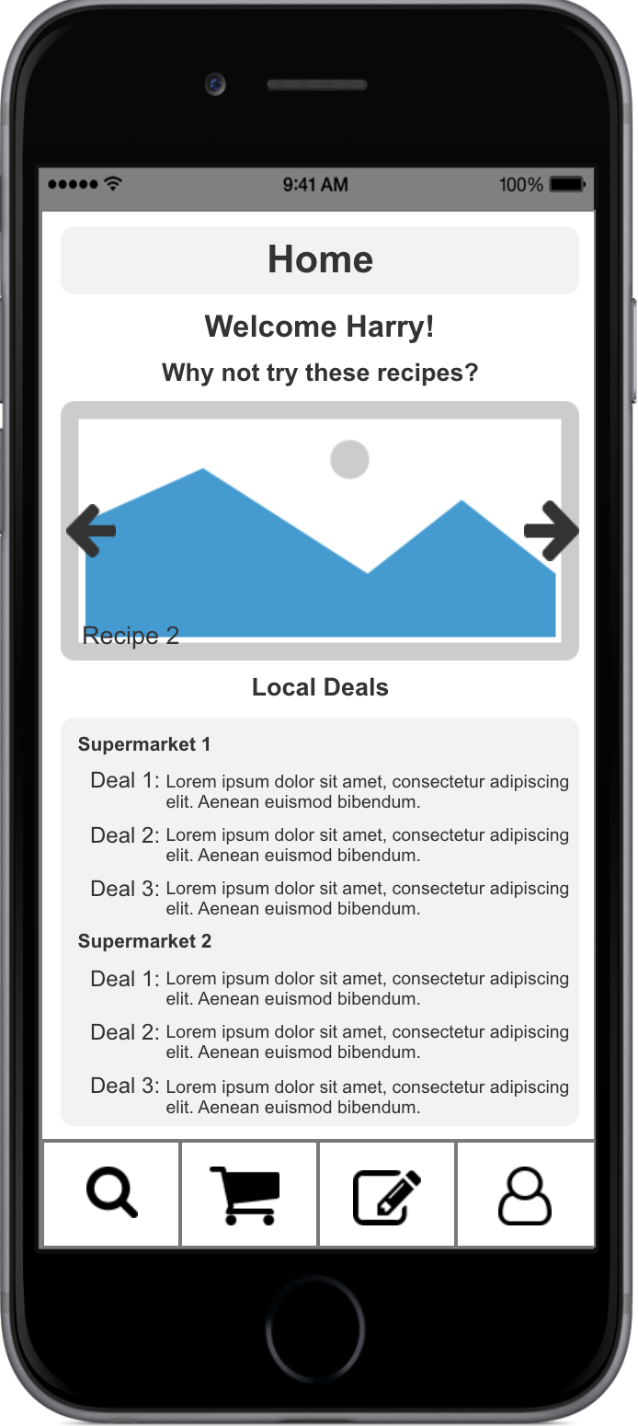 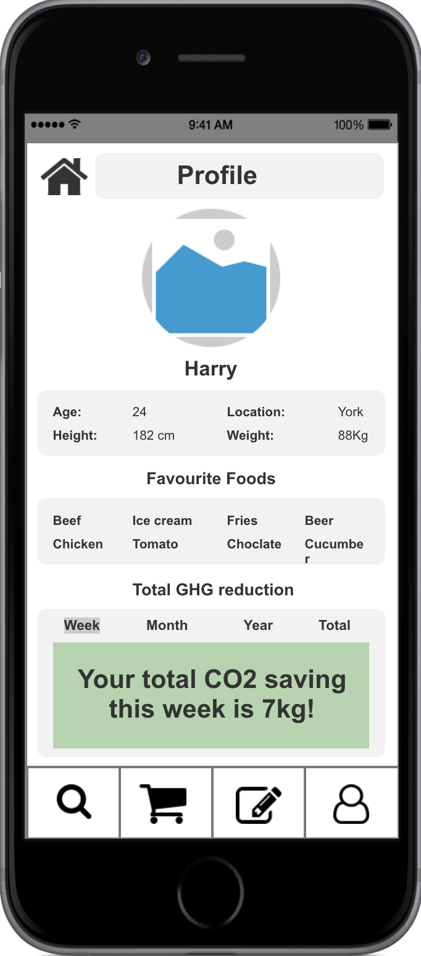

Fig. 2. The Homepage. Fig. 3. Profile page.

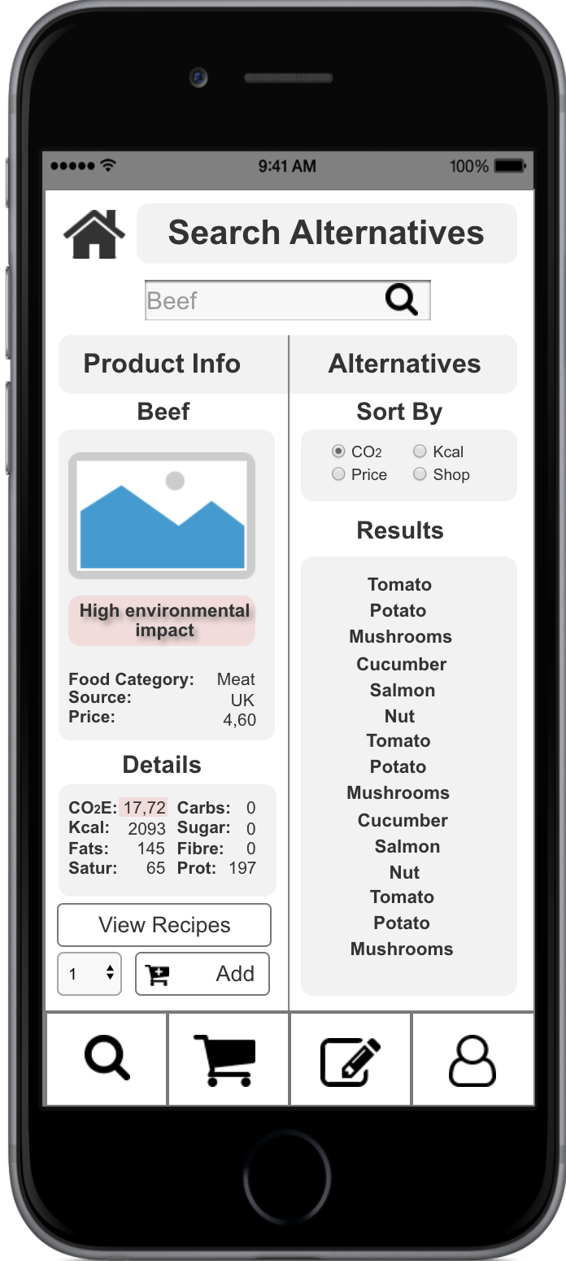 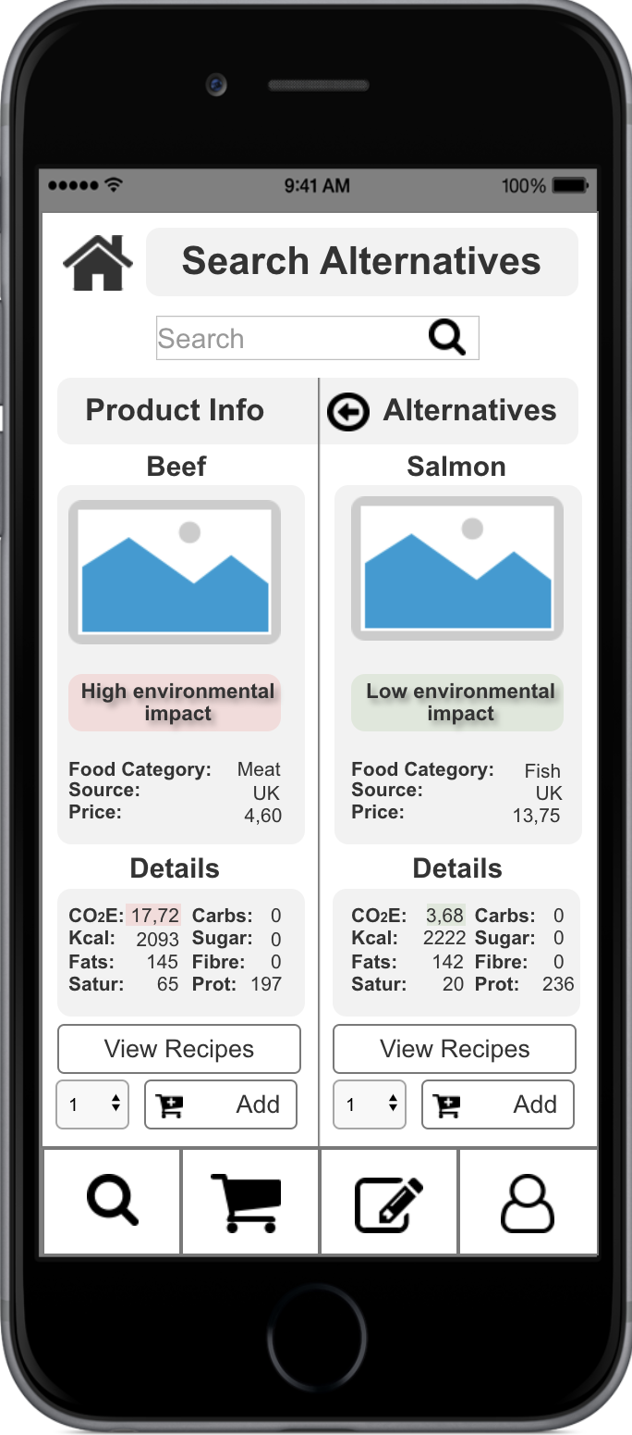

Fig. 4. The “Search Alternatives” screen. Fig. 5. The details of alternative product.

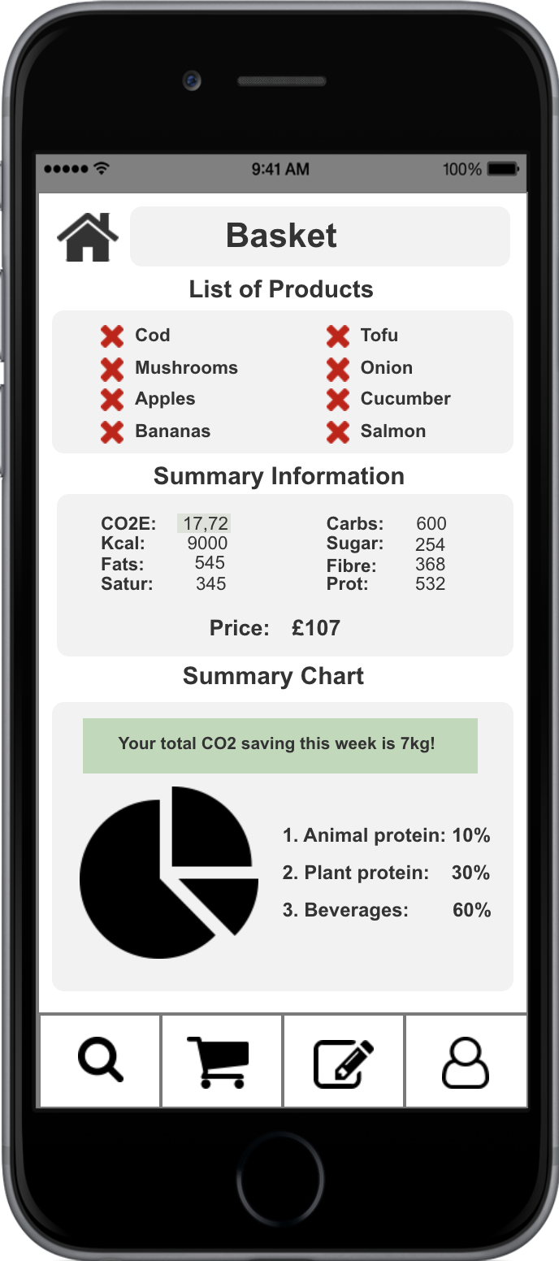 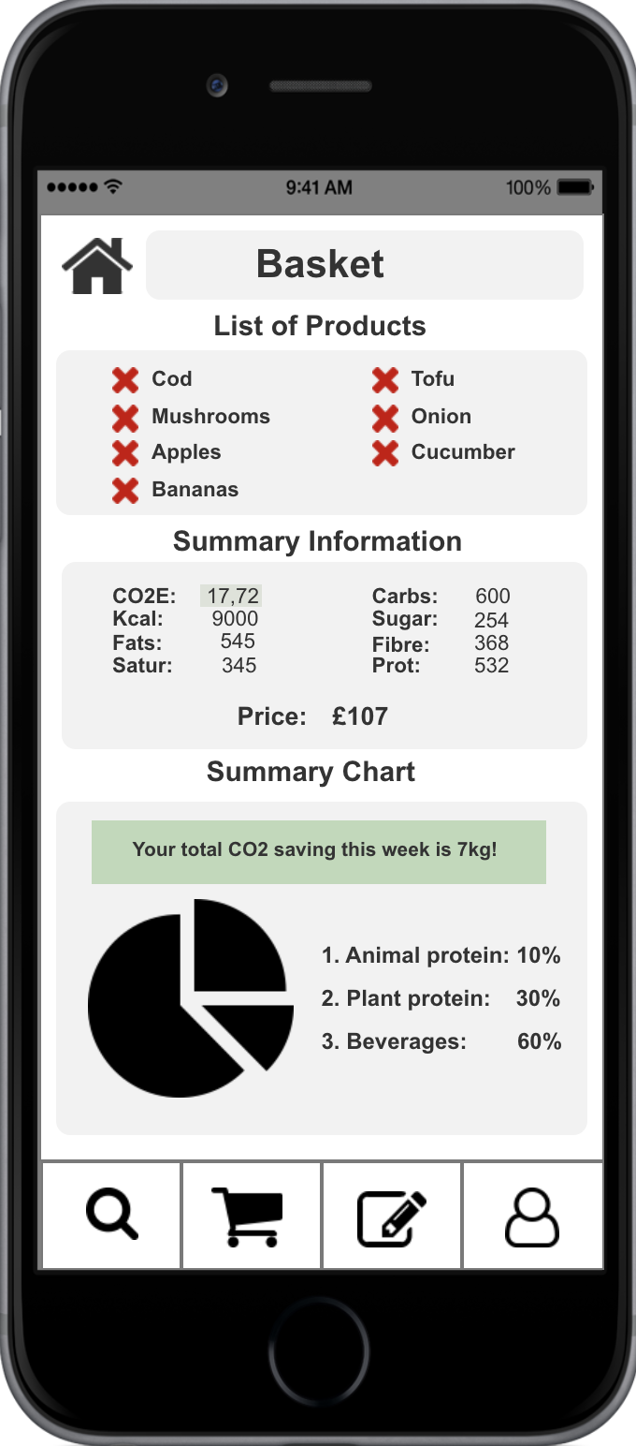

Fig. 6. The basket screen. Fig. 7. The basket screen without salmon.

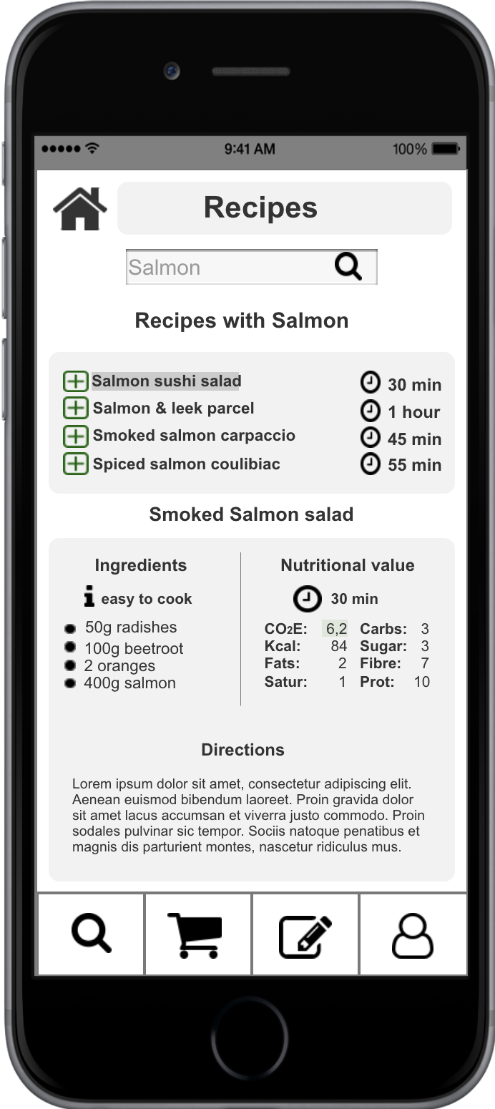 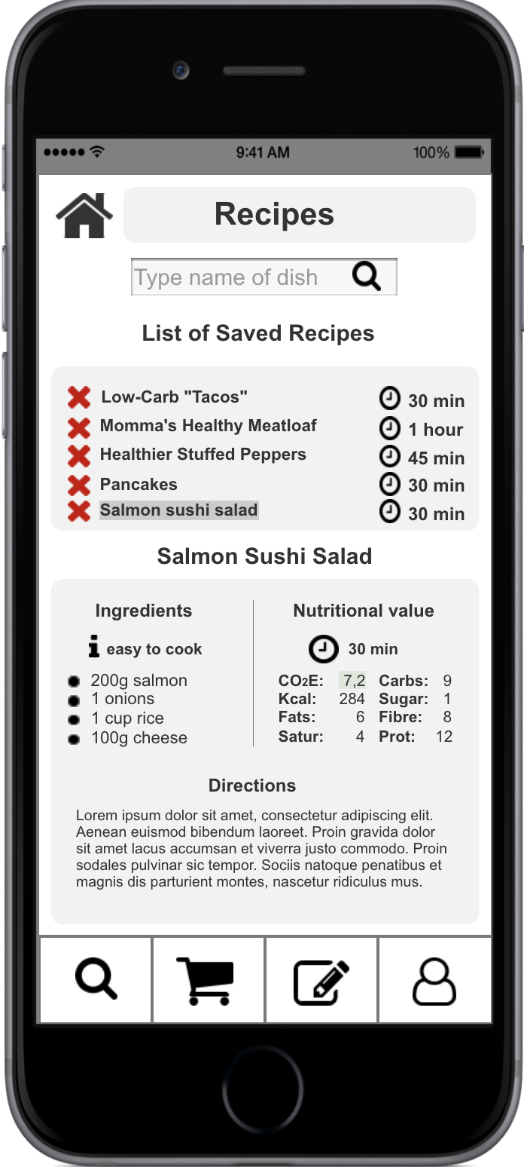

Fig. 8. The receipt search screen. Fig. 9. The screen with saved receipts.

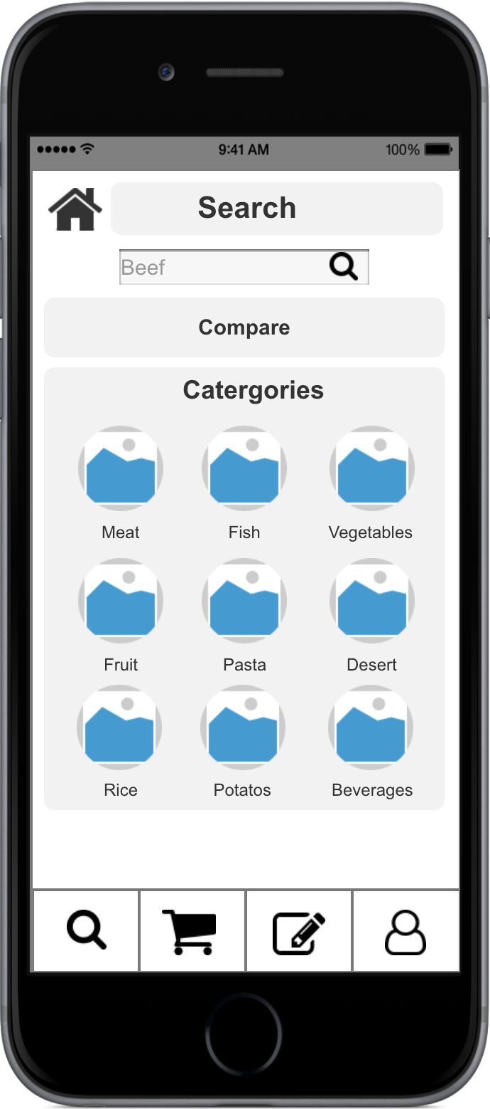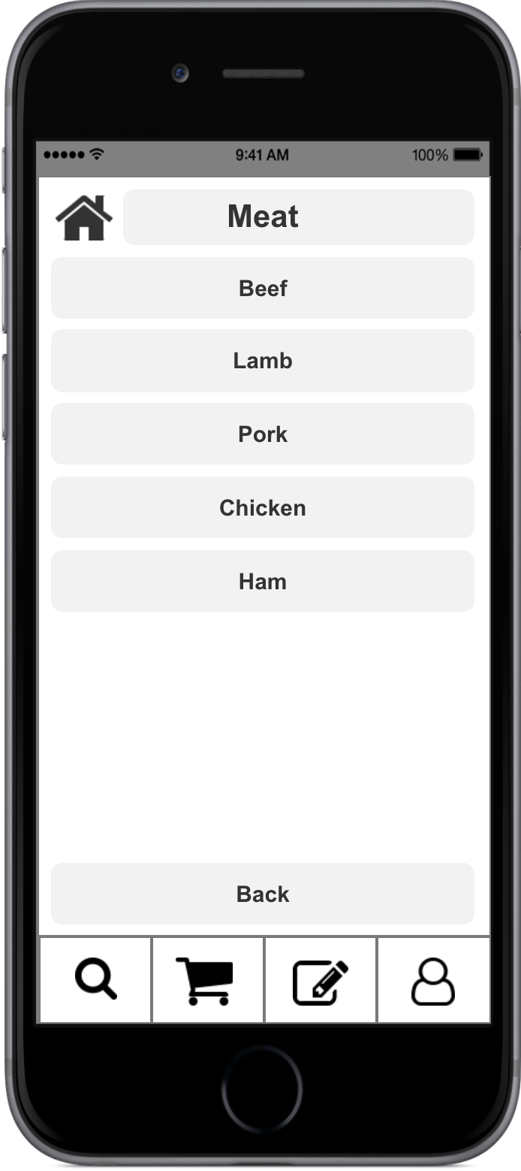

Fig. 10 Category (redesign). Fig. 11 List of products (redesign).

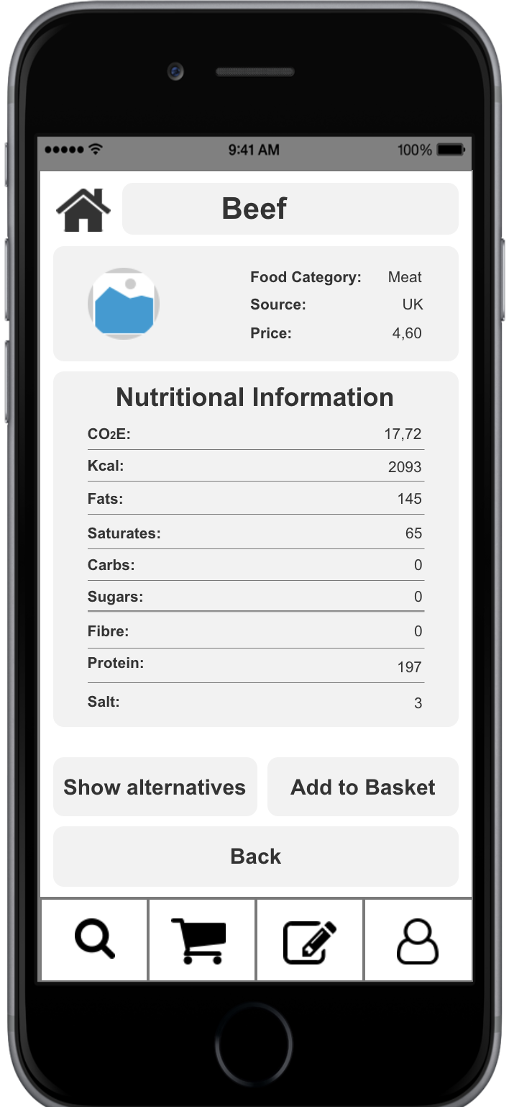 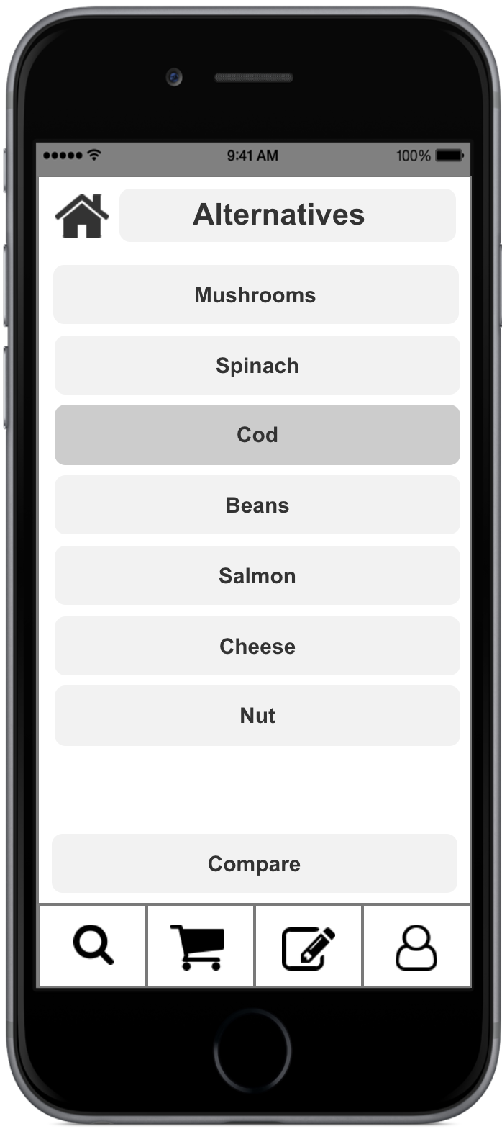

Fig. 12. The detailed information about product. Fig. 13. Alternatives page.

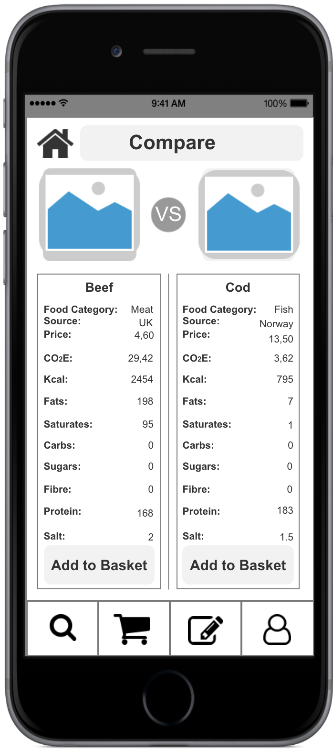

Fig. 14. Comparison page.

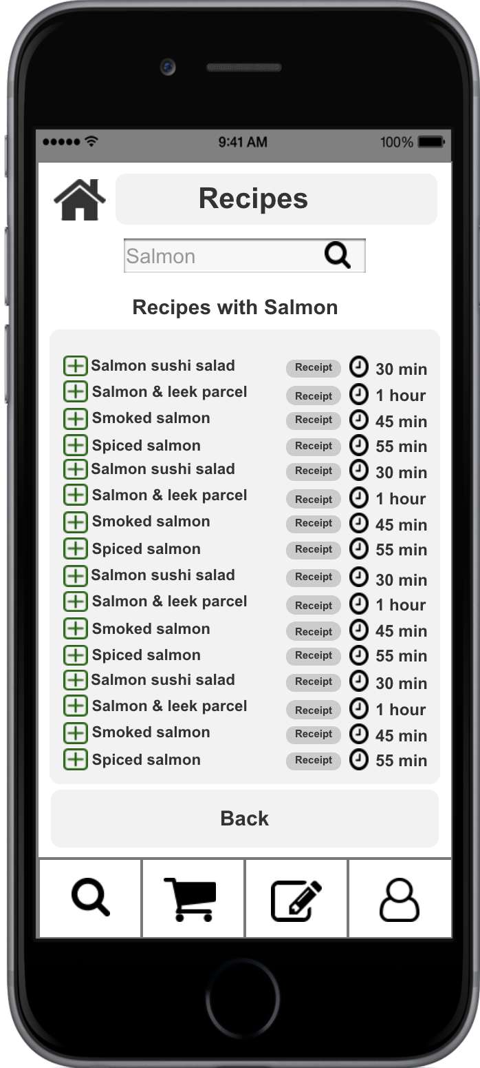 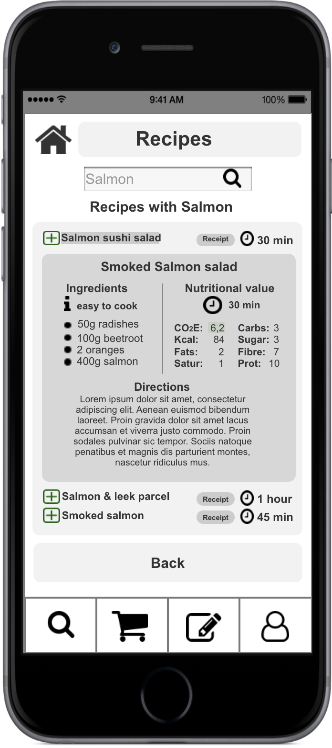

Fig. 15. Receipt redesigned page. Fig. 16. Receipt redesigned page. Receipt is opened.